**PARASHURAMA**

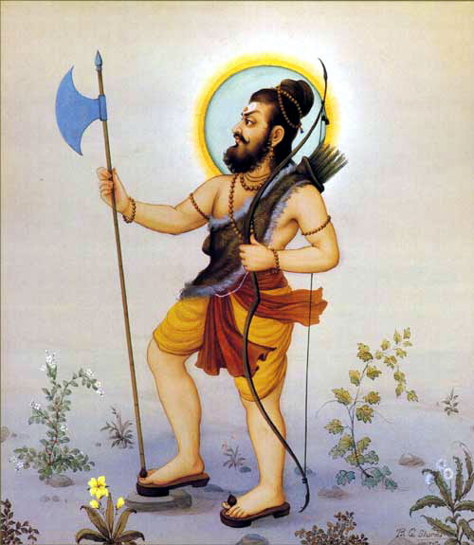

Parashurama , also referred to as Rama Jamadagnya, Rama Bhargava and Veerarama, is the sixth among the [Dashavatara](https://en.wikipedia.org/wiki/Dashavatara" \o "Dashavatara) of the god [Vishnu](https://en.wikipedia.org/wiki/Vishnu" \o "Vishnu) in [Hinduism](https://en.wikipedia.org/wiki/Hinduism" \o "Hinduism).

He is believed to be one of the *[Chiranjeevis](https://en.wikipedia.org/wiki/Chiranjeevis" \o "Chiranjeevis)* (long-lived ones or immortal ones), who will appear at the end of the [Kali yuga](https://en.wikipedia.org/wiki/Kali_yuga" \o "Kali yuga) to be the guru of Vishnu's tenth and last avatar, [Kalki](https://en.wikipedia.org/wiki/Kalki" \o "Kalki). He carried a number of traits, which included aggression, warfare and valor; also, serenity, prudence and patience.

Born to [Jamadagni](https://en.wikipedia.org/wiki/Jamadagni" \o "Jamadagni) and [Renuka](https://en.wikipedia.org/wiki/Renuka" \o "Renuka), Parashurama was foretold to appear at a time when overwhelming evil prevailed on the earth. The [Kshatriya](https://en.wikipedia.org/wiki/Kshatriya" \o "Kshatriya) class, with weapons and power, had begun to abuse their power, take what belonged to others by force and tyrannise people. Parashurama corrected the cosmic equilibrium by destroying the Kshatriya warriors twenty-one times.

He is married to Dharani, an incarnation of [Lakshmi](https://en.wikipedia.org/wiki/Lakshmi" \o "Lakshmi), the wife of Vishnu. He is also the Guru of [Bhishma](https://en.wikipedia.org/wiki/Bhishma" \o "Bhishma), [Dronacharya](https://en.wikipedia.org/wiki/Dronacharya" \o "Dronacharya) and [Karna](https://en.wikipedia.org/wiki/Karna" \o "Karna).

**Early Life**

According to Hindu legends, Parashurama was born to Sage [Jamadagni](https://en.wikipedia.org/wiki/Jamadagni" \o "Jamadagni) and his Kshatriya wife, [Renuka](https://en.wikipedia.org/wiki/Renuka" \o "Sanskrit language), living in a hut. His birthplace is believed to be on top of the [Janapav](https://en.wikipedia.org/wiki/Janapav" \o "Janapav) hills in [Indore](https://en.wikipedia.org/wiki/Indore" \o "Indore), [Madhya Pradesh](https://en.wikipedia.org/wiki/Madhya_Pradesh" \o "Madhya Pradesh). On top of the hills is a [Shiva](https://en.wikipedia.org/wiki/Shiva" \o "Shiva) temple where Parshurama is believed to have worshipped [Lord Shiva](https://en.wikipedia.org/wiki/Lord_Shiva" \o "Lord Shiva), the ashram (abbey) is known as Jamadagni Ashram, named after his father. The place also has a kund (pond) that is being developed by the state government. They had a celestial cow called [Surabhi](https://en.wikipedia.org/wiki/Surabhi" \o "Surabhi), which gives all they desire (Surabhi was the daughter of cow *[kamadhenu](https://en.wikipedia.org/wiki/Kamadhenu" \o "Kamadhenu)*). A king named [Kartavirya Arjuna](https://en.wikipedia.org/wiki/Kartavirya_Arjuna) (not to be confused with [Arjuna](https://en.wikipedia.org/wiki/Arjuna" \o "Varna (Hinduism)) the Pandava)– learns about it and wants it. He asks Jamadagni to give it to him, but the sage refuses. While Parashurama is away from the hut, the king takes it by force. Parashurama learns about this crime, and is upset. With his axe in his hand, he challenges the king to battle. They fight, and Parushama defeats and kills the king, according to the Hindu mythology. The warrior class challenges him, and he kills all his challengers. The legend likely has roots in the ancient conflict between the Brahmin [varna](https://en.wikipedia.org/wiki/Varna_(Hinduism)), with knowledge duties, and the Kshatriya varna, with warrior and enforcement roles.

In some versions of the legend, after his martial exploits, Parashurama returns to his sage father with the Surabhi cow and tells him about the battles he had to fight. The sage does not congratulate Parashurama but reprimands him stating that a Brahmin should never kill a king. He asks him to expiate his sin by going on pilgrimage. After Parashurama returns from a pilgrimage, he is told that while he was away, his father was killed by Kartavirya Arjun's Sons seeking revenge. Parashurama again picks up his axe and killed them and also kills many warriors in retaliation. In the end, he relinquishes his weapons and takes up [Yoga](https://en.wikipedia.org/wiki/Yoga" \o "Yoga).

In [Kannada](https://en.wikipedia.org/wiki/Kannada" \o "Kannada) folklore, especially in devotional songs sung by the [Devdasis](https://en.wikipedia.org/wiki/Devdasi" \o "Devdasi) he is often referred to as a son of [Yellamma](https://en.wikipedia.org/wiki/Yellamma" \o "Yellamma).

Parasurama legends are notable for their discussion of violence, the cycles of retaliations, the impulse of *krodha* (anger), the inappropriateness of *krodha*, and repentance.

**Ramabhadra to Parashuram**

Parshuram’s birth name is believed to be Rama and some Rambhadra, he is also known by the names Bhargava, Bhrigupati, Jamadagnya, Bhriguvanshi, etc. It is believed that for the destruction of sinners, he did the hard penance of Lord Shiva and got the blessings of mastering the art of warfare from him.

He also received many unique weapons from [Lord Shiva](https://rgyan.com/blogs/tag/lord-shiv/), one of them was Lord Shiva’s Parshu which is also known as Fursa or axe. He was very dear to them and always kept it together. He was called Parashurama only because of wearing a Parshu.

**Akshaya Tritiya and Parshuram born**

Lord Parshuram was born on Vaishakh Shukla Tritiya. It is also considered to be the [Akshaya Tritiya](https://rgyan.com/blogs/akshaya-tritiya-the-most-magical-day-for-good-fortune/) one of the most auspicious days of the [Hindu calendar](https://rgyan.com/blogs/tag/indian-calendar-2020/). ‘Akshay’ means ‘which never decays’, which means that it never perishes. Thakur Ji’s Charan Darshan takes place on this day in Vrindavan, Uttar Pradesh state of India.

Akshaya Tritiya is also commonly referred to as ‘Akhtij “or’ Akha Teej”. The Tritiya date of Shukla Paksha in Vaishakh month is popularly known as “Akshaya Tritiya”. Akshaya Tritiya was incarnated by Lord Vishnu as Parashurama.

**Stories related to Parashuram :**

**The killing of Jamadagni**

Parshuram’s parents were spiritual people and his father Jamadagni had his ashram on the bank of the river. It was there where he imparted education to his sons and disciples.

One day, while he was performing yajna, he asked his wife Renuka to fetch some water from the river for oblation. Renuka went as asked to fetch some water but she lost track of time and missed oblation as celestial singer Chitraratha was indulging in leisure activities with his wife in the river.

Sage Jamadagni was so angry at his wife’s carelessness that he asked his sons to behead her. No son came forward. Seeing this, Lord Vishnu Avatar Parshuram picked his axe and killed his mother. His father was very impressed and offered him a boon.

Parshuram asked for the life of his dead mother back. By then, Jamadagni’s anger had subsided and thus he brings his wife back to life.

### The incident with the cow

Jamadagni and Renuka had a magical cow called Kaamdhenu that was the symbol of abundance. It had emerged out of the ocean during the great churning. One day when the sage and his sons were away and Renuka was alone, a few Kshatriyas came to visit, Renuka offered them food and delicious milk from the cow.

The Kshatriyas on seeing this and finding out about the cow decided to take it to king Arjuna. They asked for the cow and Renuka refused. However, while leaving, The Kshatriyas seized the cow and took it with them anyway.

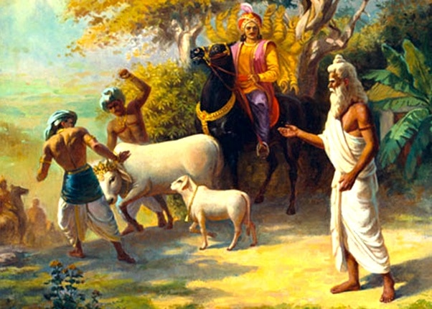

Parshuram came back to his mother wailing and was very angry. He at once stormed to Mahishmati, the capital of Arjuna. Seeing him, Arjuna mocked him and told him that his father and he should only indulge in Penance and forget about Kaamdhenu as only Kshatriyas deserve the best of all things.

He sent his army to face Bhagwaan Parshuram who is the Avatar of God Vishnu and not one did survive. Arjuna was too furious to see his army destroyed. So, he went on his own to fight Parshuram.Arjuna completely forgot about the curse that was spelled upon him by Muni Vashisth after Arjuna had once burnt a forest down. The curse was meant for him to be killed by a very powerful man and he was to cut off all the thousand arms of Arjuna. The curse did turn into reality and Arjuna’s all thousand arms were cut off by Parshuram followed by his beheading.

### Parashurama Kills Kartavirya Arjuna | MasterArtKartavirya Arjuna killed by Parashuram

### That incarnation of God is known as Jamadagnya (Parashurama). For what and when did he take incarnation in Bhrigukul, he tells the episode, listen.

King Yudhishthira! Parshuram, the son of Maharishi Jamadagni, is very powerful. Parashurama, the best among the strong men, killed the Haihayavansh. Mahaparakrami Kartavirya did not keep his life in the Arjuna force but was killed by Jamadagninandan Parasurama because of his improper behavior.

ShatruSudan Haihayaj Kartavirya was sitting on the Arjuna chariot, but in the battle, Parashuramaji killed him by knocking him down. It was Lord Govind who emerged in the Bhrigu dynasty as Parashuram. This is the one who disguises the head of Jambasur and is fatal to Shatdundubhi. He incarnated only to kill Sahasrabahu Arjuna, who had won thousands of battles, in the war. Mahayashasvi Parashurama had conquered the six hundred and forty thousand Kshatriyas gathered on the banks of the Saraswati river with the help of a bow.

**Role in Mahabharata**

He plays important roles in the *[Mahabharata](https://en.wikipedia.org/wiki/Mahabharata" \o "Mahabharata)* serving as mentor to [Bhishma](https://en.wikipedia.org/wiki/Bhishma" \o "Bhishma) (chapter 5.178), [Drona](https://en.wikipedia.org/wiki/Drona" \o "Drona) (chapter 1.121) and [Karna](https://en.wikipedia.org/wiki/Karna" \o "Karna) (chapter 3.286), teaching weapon arts and helping key warriors in both sides of the war.

In the regional literature of [Kerala](https://en.wikipedia.org/wiki/Kerala" \o "Kerala), he is the founder of the land, the one who brought it out of the sea and settled a Hindu community there. He is also known as Rama Jamadagnya and Rama Bhargava in some Hindu texts. Parashurama retired in the [Mahendra Mountains](https://en.wikipedia.org/wiki/Mahendra_Mountains" \o "Mahendra Mountains), according to chapter 2.3.47 of the *[Bhagavata Purana](https://en.wikipedia.org/wiki/Bhagavata_Purana" \o "Bhagavata Purana)*. He is the only Vishnu avatar who never dies, never returns to abstract Vishnu and lives in meditative retirement.

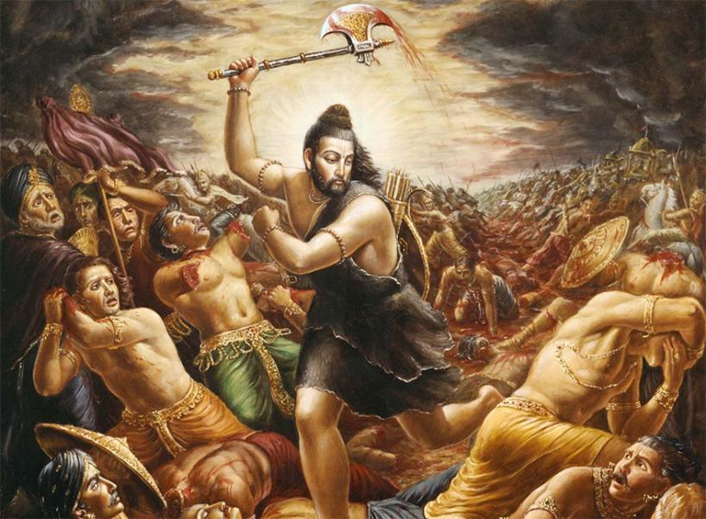

Further, he is the only Vishnu avatar that co-exists with other Vishnu avatars Rama and Krishna in some versions of the *Ramayana* and *Mahabharata*, respectively.

**Parashurama Kshetras**

There is much interpretation of Parashurama kshetras.

The ancient Saptakonkana is a slightly larger region described in the Sahyadrikhanda which refers to it as Parashuramakshetra (Sanskrit for "the area of Parashurama"), [Vapi](https://en.wikipedia.org/wiki/Vapi" \o "Vapi) to [Tapi](https://en.wikipedia.org/wiki/Tapi_district" \o "Tapi district) is an area of South [Gujarat](https://en.wikipedia.org/wiki/Gujarat" \o "Parshuram Kund), India. The area blessed by Lord Parshuram and called "Parshuram ni bhoomi".The region of [Konkan](https://en.wikipedia.org/wiki/Konkan" \o "Konkan) is also considered as Parashurama Kshetra.

There is a [Parshuram Kund](https://en.wikipedia.org/wiki/Parshuram_Kund), a Hindu pilgrimage centre in [Lohit district](https://en.wikipedia.org/wiki/Lohit_district) of [Arunachal Pradesh](https://en.wikipedia.org/wiki/Arunachal_Pradesh" \o "Arunachal Pradesh) which is dedicated to the sage Parashurama. Thousands of pilgrims visit the place in winter every year, especially on the [Makar Sankranti](https://en.wikipedia.org/wiki/Makar_Sankranti" \o "Shankaranarayana) day for a holy dip in the sacred kund which is believed to wash away one's sins.

Mahurgad is one of the Shaktipeeth in [Maharashtra's](https://en.wikipedia.org/wiki/Maharashtra" \o "Maharashtra) [Nanded district](https://en.wikipedia.org/wiki/Nanded_district" \o "Nanded district), where a famous temple of Goddess [Renuka](https://en.wikipedia.org/wiki/Renuka" \o "Renuka) exists. This temple at Mahurgad is always full of pilgrims. People also come to visit Lord Parashuram temple on the same Mahurgad.In [Karnataka](https://en.wikipedia.org/wiki/Karnataka" \o "Karnataka), there are a group of 7 temples in the stretch of [Tulunadu](https://en.wikipedia.org/wiki/Tulunadu" \o "Tulunadu) (coastal Karnataka), known as Parashurama Kshetras, namely, [Kollur](https://en.wikipedia.org/wiki/Kollur,_Udupi_district" \o "Kollur, Udupi district), [Koteshwara](https://en.wikipedia.org/wiki/Koteshwara" \o "Koteshwara), [Kukke,Subrahmanya](https://en.wikipedia.org/wiki/Kukke_Subrahmanya" \o "Kukke Subrahmanya), [Udupi](https://en.wikipedia.org/wiki/Udupi" \o "Udupi), [Gokarna](https://en.wikipedia.org/wiki/Gokarna,_Karnataka" \o "Gokarna, Karnataka), [Anegudde](https://en.wikipedia.org/wiki/Anegudde" \o "Anegudde) (Kumbhasi) and [Shankaranarayana](https://en.wikipedia.org/wiki/Shankaranarayana" \o ").The temple called Athyarala in [Rajempet](https://en.wikipedia.org/w/index.php?title=Rajempet&action=edit&redlink=1" \o "Rajempet (page does not exist)), [Andhra Pradesh](https://en.wikipedia.org/wiki/Andhra_Pradesh" \o "Andhra Pradesh), is dedicated to Parashuram.